

Programme Name: ________**BCS HONS**_______________________________________

Course Code: __**CSC 1020**________

Course Name: ________**Introduction to Ecommerce**______________________________

Lab Sheet/ **Project** / Case Study No. _**1**___

Date of Submission: ______**1/31/2020**_____________

**Submitted By: Submitted To:**

Student Name**: Dipesh Tha Shrestha** Faculty Name**: Kushal Regmi**

IUKL ID: **041902900028** Department**: LMS**

Semester**: Third Semester**

Intake**: September 2019**

**Introduction**

* **Alibaba.com** is a Chinese multinational technology company specializing in e-commerce, retail, Internet, and technology.
* Founded on 28 June 1999, in Hangzhou, Zhejiang.
* The company provides consumer-to-consumer (C2C), business-to-consumer (B2C), and business-to-business (B2B) sales services via web portals, as well as electronic payment services, shopping search engines and cloud computing services. It owns and operates a diverse portfolio of companies around the world in numerous business sectors.

**Features**

* Allows them to talk with the sellers freely
* Everything is trackable
* Share your purchases
* Internal re-marketing
* live stream shopping
* Attracting Sellers by Eliminating listing fees
* Multi language sites

**Official site of Alibaba**

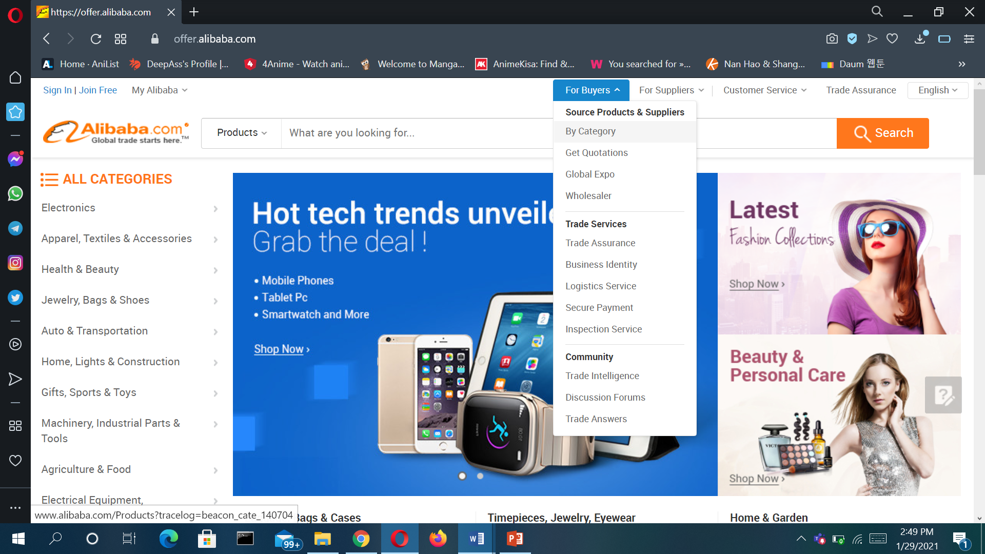

**Types of e-commerce that have been used in Alibaba**

1. **Alibaba B2B**
   * Alibaba.com was launched in 1999 in Hangzhou by Jack Ma, a former English teacher, along with a group of 17 friends. It is a **business-to-business** trading platform, connecting manufacturers and wholesalers with buyers from around the world.
   * Merchants pay annual sellers' fees and sales commissions to Alibaba. They can list a limited number of products for free but have the option to pay for a range of benefits such as greater exposure on the site and unlimited product listings.

**2. Taobao C2C**

* While Alibaba.com is business-to-business, Taobao is **business-to-consumer**or**consumer-to-consumer** focused, enabling small businesses and individuals to open online stores.
* Taobao.com has grown to become China's largest shopping website. Launched in 2003, Taobao lists hundreds of millions of products and services from millions of sellers.
* Taobao doesn't charge transaction fees and the site is free for merchants to join, a policy that helped the site gain its enormous user base in China. Its main revenue source is advertising fees paid by merchants who want to stand out from the literally millions of competitors on the site.

**3. Tmall B2C**

* Tmall is a Chinese-language website for **business-to-consumer (B2C)** online retail.
* It is a platform for local Chinese and international businesses to sell brand name goods to consumers.
* Tmall is the part of Alibaba that most resembles eBay and Amazon, which also collect transaction fees from third-party merchants.

**Business models being used in Alibaba**

* The company provides **consumer-to-consumer (C2C), business-to-consumer (B2C),** and **business-to-business (B2B**) sales services via web portals, as well as electronic payment services, shopping search engines and cloud computing services.

**Alibaba Sites**

* **Alibaba.com.**
* **Alibaba Cloud.**
* **AliExpress.**
* **AliOS.**
* **Alipay.**
* **AliGenie.**
* **Taobao.**
* **Tmall.**

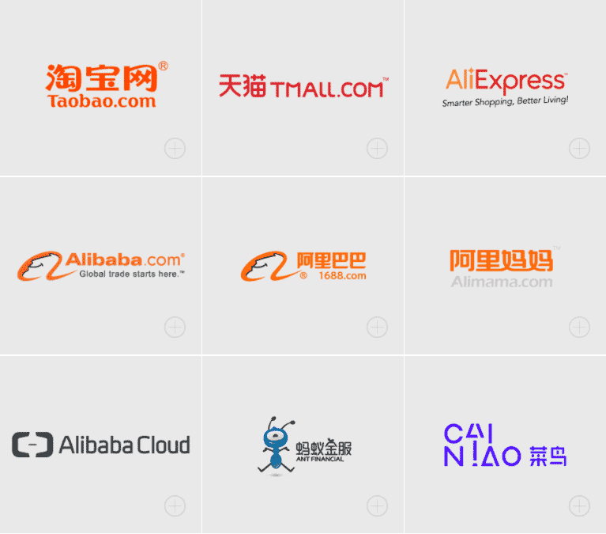

**How to Buy from Alibaba**

In order to start buying from Alibaba, it’s important to know just how to buy from Alibaba! Here are the steps to successfully make purchases on the website:

* Create and verify an Alibaba account
* Search for products based on different categories
* Contact suppliers
* Negotiate minimum order quantity
* Verify offered price to avoid dealing with hidden charges
* Negotiate price and payment method
* Ask for samples
* Confirm quality of products through samples
* Make your purchase
* Resell the product on your own online store after it arrives

**Advantages of Buying from Alibaba:**

* Ability to design your own custom-made products
* Ability to buy bulk wholesale products directly from manufacturers
* Affordable prices
* Increased control over product packaging
* Lower manufacturing costs
* Huge number of manufacturers and suppliers to choose from
* One-stop shopping option

**Disadvantages of Buying from Alibaba:**

* Higher upfront cost
* Reality of products may differ from display images on website
* Maximum order amount needed for discounted pricing

**Strategy Alibaba can take to provide better services**

* Site speed
* Use High-Quality Photographs and Good Product Descriptions
* Improve Your Social Media Strategy
* Build Advertising Strategies
* Implement User-Generated Content
* Increase E-commerce Search Usability

**New technologies company has implemented**

* Alibaba used an **intelligent operating platform, DC Brain**, to optimise the performance of the 200-plus global internet datacentres (IDCs) hosting its online stores in areas including energy consumption, temperature, energy efficiency, and reliability.
* Alibaba use **global tracking system**. It uses Internet of Things (IoT) and blockchain technology to verify products purchased by consumers through dual authentication and two-way encryption, while tracking the real-time location of items through location-based services and GPS.
* The mobile-based technology**(Smart touch)** was made available to assist shoppers that are visually impaired. The application can understand different mobile user interfaces through AI and intelligent human-machine-interaction (HMI) technology to provide the relevant audio and haptic interactions.
* Alibaba developed an AI translation tool in a bid to remove language barriers between sellers and buyers. **Online chatbot** provides instant translation from English to Thai, Vietnamese, Indonesian, and vice-versa.

**Marketing and Advertising techniques used**

* **Distribution strategy in the Marketing strategy of Alibaba –**

Technologically advanced and robust infrastructure has helped the company in providing a seamless and easy to access and communicate, sell, buy the different offerings of the sellers/ buyers anywhere, anytime across the world.

* **Competitive analysis in the Marketing strategy of Alibaba –**

Alibaba’s diversified business portfolio is helping the company to be competitive while the e-commerce market is overcrowded with local, national and international players like Amazon, eBay etc

* **Customer analysis in the Marketing strategy of Alibaba –**

Customers of Alibaba are new-age, tech-savvy, Gen Y and Z customers to whom their time, the convenience of buying and selling, maintaining their lifestyle is more important than it ever had.

* **Market analysis in the Marketing strategy of Alibaba –**

Alibaba has the presence in China and various international markets. It had 423 MM active buyers in the year 2015-16 who helped the company in surpassing 3 trillion Renminbi (RMB) of Gross Merchandise Value.  Alibaba is ruling the market in China but in other Developing and Developed nations, it is still struggling to emerge as a most preferred e-commerce player.

* **Promotion Strategy of Alibaba company**

The company also promotes its services via internet promotion strategy such as public relations, direct marketing, and discounts for certain items during special days such as festivals, media advertising and sponsoring of events to attract awareness of Alibaba .

**Thank you**